Rural Development

Webx

TEAM NO.: 67

Presented BY:

1. Rishabh goel-RA1511008010330
2. Achintya Pandey- RA1511008010334
3. Kartik Bhojak- RA1511008010352
4. Aditya Patnaik- RA1511008010354
5. Kushagra jaiswal- RA1511008010400

Guide: Mr.J.prabakaran

2018

**Objective**

The objective of this project is to provide a common platform for NGOs which would give them the power of being heard. This project is intended to:

• Create a greater awareness about different NGOs and their requests;

•To bring attention to environmental, financial ,natural losses as a cross-cutting issue; to **highlight** the contribution of a specific NGO.

• Increase access to information about the requirements for other NGOs who are starting to venture the field.

• Promote the causes that are intended for public good.

**Problem statement**

* To develop a **common platform** for NGOs .
* To create greater awareness about **NGO requests** and **requirements**.
* Providing a **single goto** for a user to turn into a donator.
* Providing a differentiated **NGO list** keeping in mind the focus that a particular NGO has interms of area being **Rural or Urban**.
* To support **Global issues** by taking **insights** from people visiting the platform.
* To answer **requirement related queries** of the user using A.I.
* To provide an **abstract messenger** to the user to improve Web User Satisfaction.

**Literature review**

**Apache Web Server**

Modern web servers such as apache are capable of operating in both multi-threaded and multi-process modes. In multi-threaded mode, Apache is structured as a pool of worker threads to handle HTTP requests. A worker thread processes the request until it completes and then accepts a new request. In the thread pool model, the threads are pre-created at the start up.

**Php**

PHP is a server side, cross platform, html embedded scripting language. The engine that runs php is the middleware that generates dynamic contents.

PHP’s modular design provides modules for ,Database connectivity for popular database such as Oracle, MS-SQL server. Here the focus is more on PHP’s interaction with MySQL database and Apache web server.

PHP acts as a module in Apache server itself and shares the same process address space of the webserver . Hence doesn’t have any inter-process communication overhead with the server. Disadvantage of this architecture is in the situations when the web server is the bottleneck there is no chance to offload PHP middle tier into a separate machine.

**MySQL**

MySQL is also a multi-threaded server where a thread cache is used instead of thread pool model. Thread in a thread cache are managed in dynamic fashion and they are not pre-created at start up. When the number of threads needed to serve the requests exceeds the thread cache size new threads will be created.

**Engati-ChatBot**

A **chatbot** is a computer program which conducts a conversation via auditory or textual methods. Such programs are often designed to convincingly simulate how a human would behave as a conversational partner, thereby passing the Turing test.

We have integrated the chatbot to answer user queries related to the NGOs and their requirements.

**Pubble-Community**

We have integrated a user community to support discussion on various topics in situ with global needs.

**Software Hardware requirement**

Software/Technology used at client end:

* Html
* Css
* Animate.css
* Bootstrap
* LightBox Model
* JavaScript
* Jquery
* Wow.js

Software/Technology used at server end:

* Server used Xampp
* Php
* Php mailer implemented on Gmail Server
* Database- Sql

Miscellaneous Integrations

* Google Maps
* Google Charts
* Engati Chat Bot
* Pubble-Forum

**Modules/Integrations**

Signup

Login(Session)

NGO Personalised Panel

Admin Panel and Login

Automatic Mail Generation using php mailer(SMTP)

Sql Module

Forum Integration

Chat Integration

**Implementation details**

**Signup**

NGO is made to register using the sign-up page that is form based.

The NGO-signup data is fed to the **registration table.** On the Admin Panel, the user is approved using the ngo-id column in registration table. If the user is disapproved, the entry from the registration table is deleted.

An auto generated reply mail is sent to the user, once approved, otherwise the user is notified with a disapproval mail. An e-mail is sent to the team.

**Login: check(email, pass, status) from registration table**

When the NGO logs in, the email-id is being looked up in the registration table and the status column is checked for approval. If the status is set to approved, only then the password is being further matched with the password mentioned in the table.

**NGOPanel:**

**set requirements (radio button-food,monetary,clothes,others)**

Once the NGO has successfully logged in, he can see the NGO Panel on the screen. On clicking the set requirements tab, the requirements page is displayed with different categories to request on.

Once the NGO is done with the requirement data entry,he can click on submit to log the entries on the NGO-requirements table.

**Donate page –Join (registration table data, ngo-requirement table data)**

On successful submission of NGO requirement in the set requirement tab on the NGO panel, a Join operation is used to fetch the data from two tables (registration table and ngo-requirement table). The requirement is now displayed on the donate page for the viewers/users.

On clicking the donate button for a specific requirement, a form is displayed with a QR-code on it (could be scanned if the help to be made is monetary) or a link to NGO-information is displayed on the form to make contact with the NGO to help in other ways.

**NGO panel**

On the NGO Panel, there are profile and requirement analysis tabs other than the set requirements tab which provides a deep insight about the NGO information and its requests made in different categories.

The Requirement Analysis Tab displays a pictorial information of NGO-requests in different categories in the form of a Pie Chart(Google Chart).

**Screen shots of results**

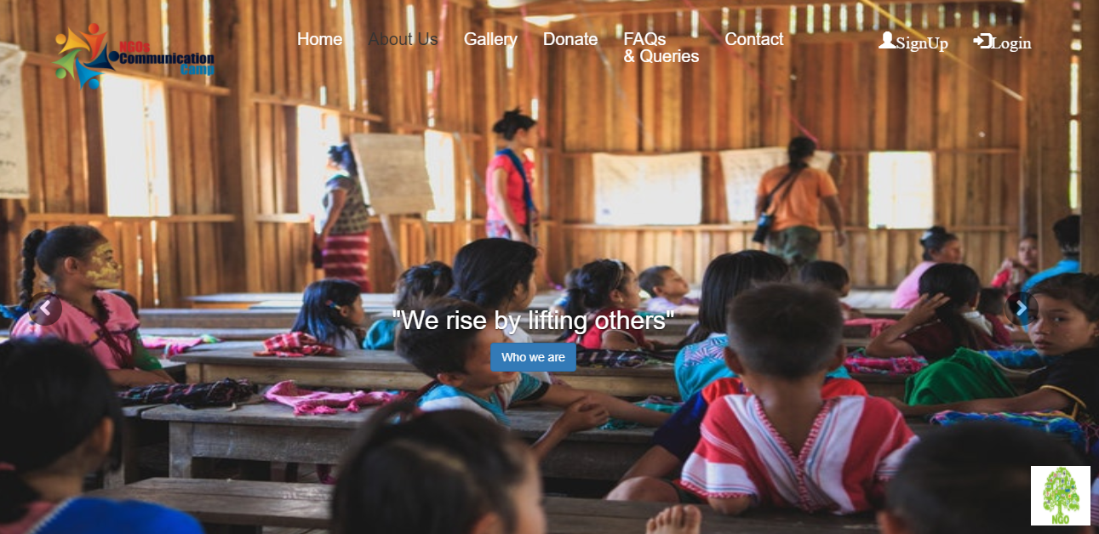

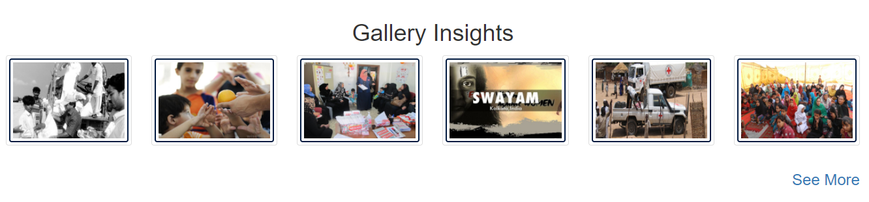

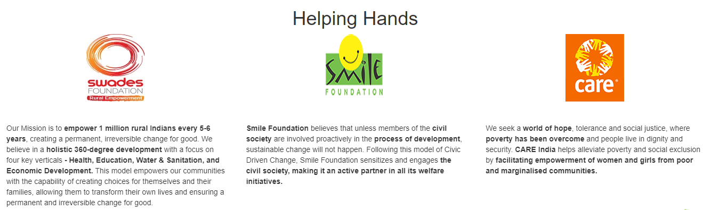

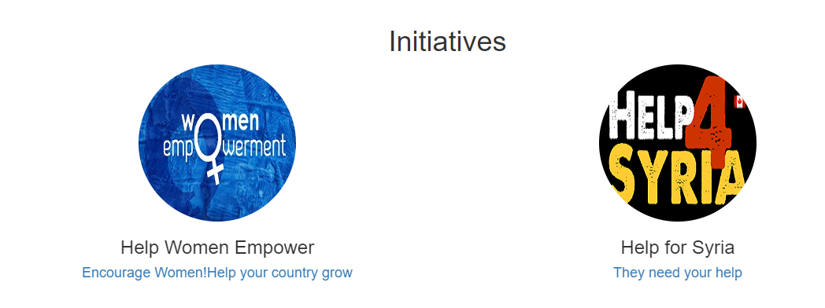

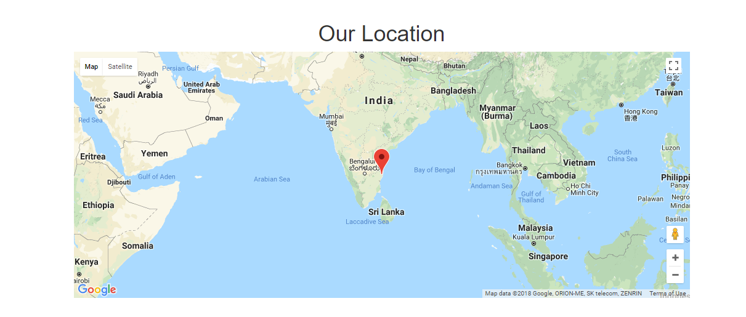

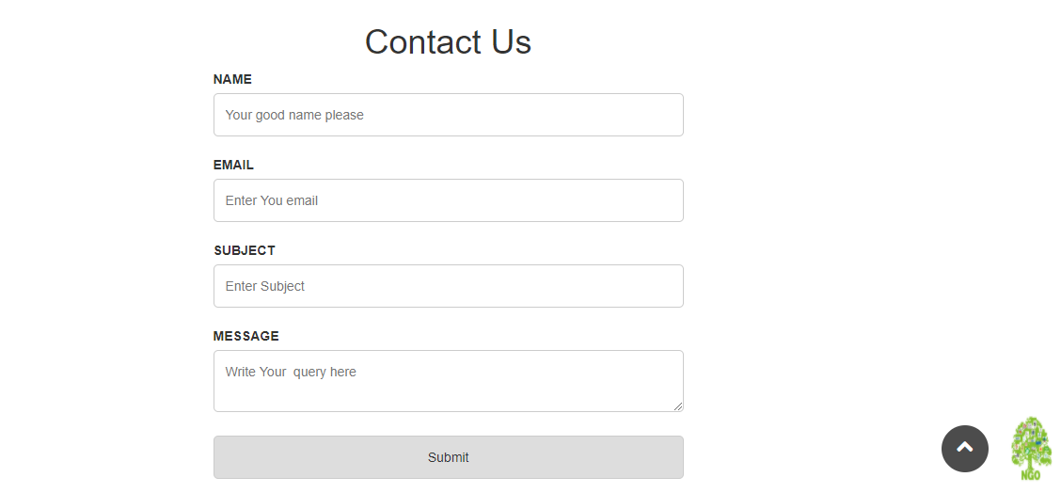

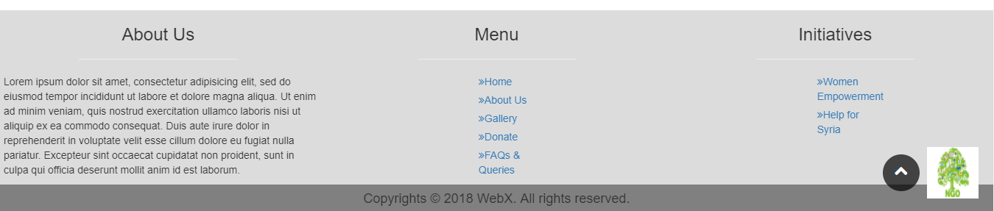

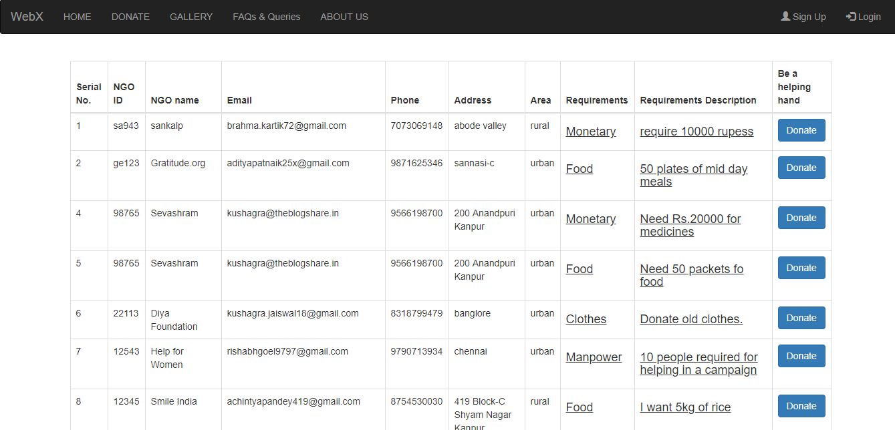

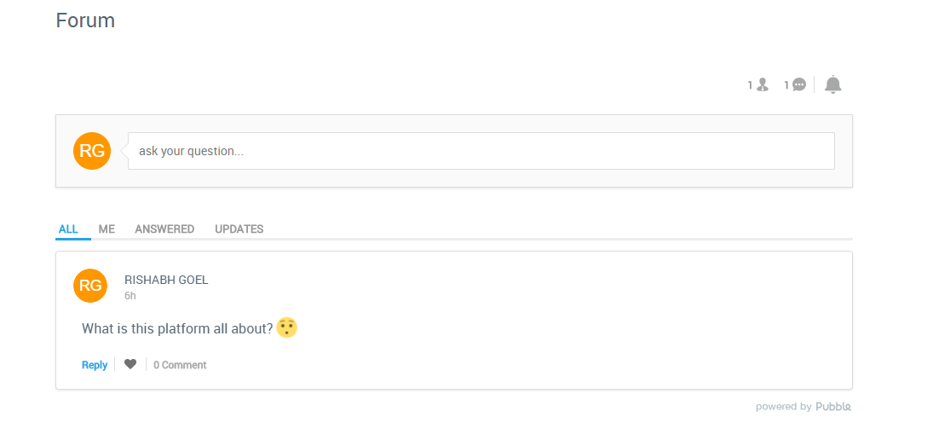

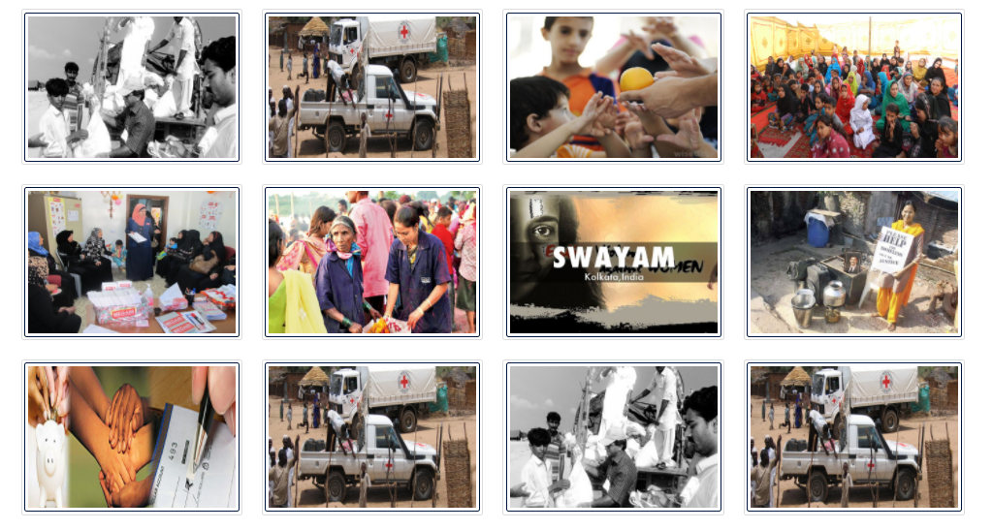

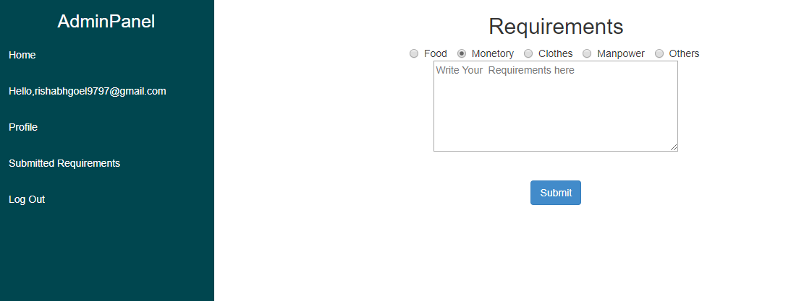

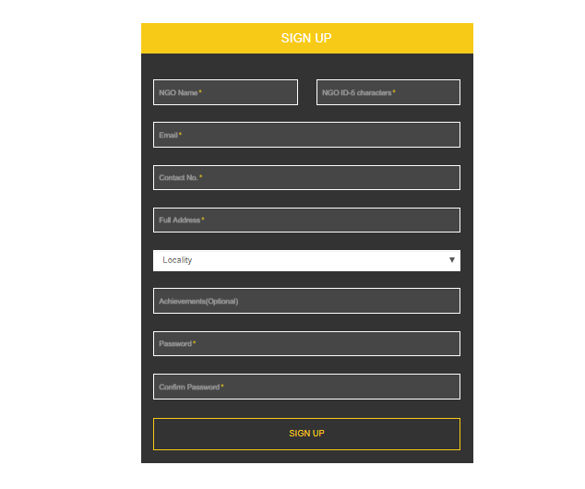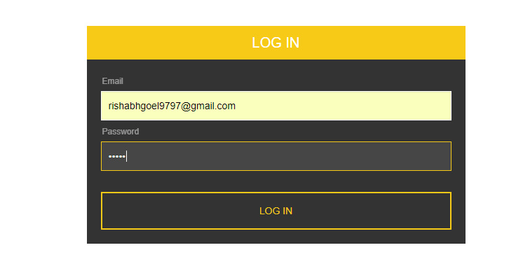

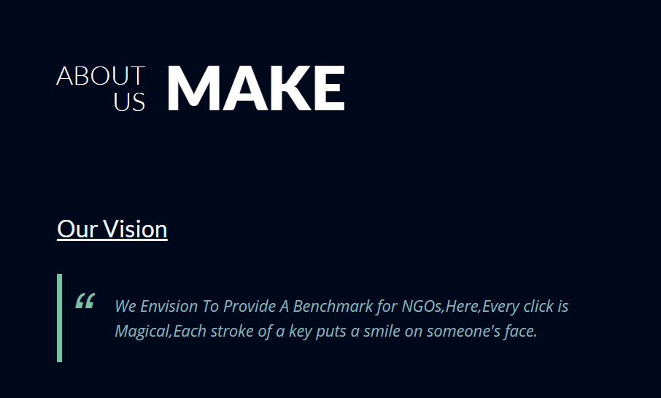

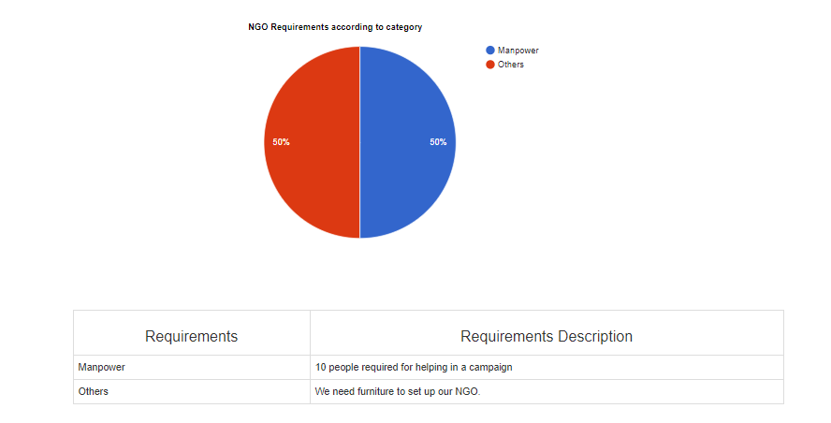

**Conclusion**

The target of the project is to provide a common platform to independent NGOs and to Organisations who are working for public good.

After all,

“A kind gesture can reach a wound that only compassion can heal”

**References**

1. <https://stackoverflow.com/>
2. <https://github.com/>
3. <https://www.w3schools.com>
4. <https://www.sitepoint.com/>
5. <https://codepen.io/>